**SQL QUERIES:**

**Union -- >Removes Duplicate**

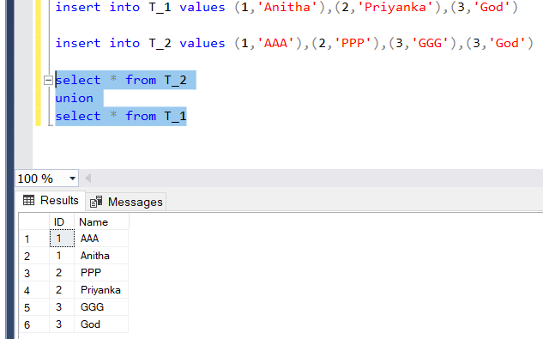

**Union All 🡪 combines all**

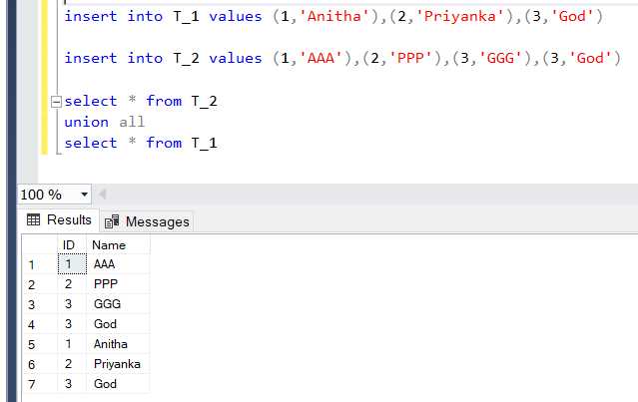

**Intersect 🡪 Only the common will be shown**

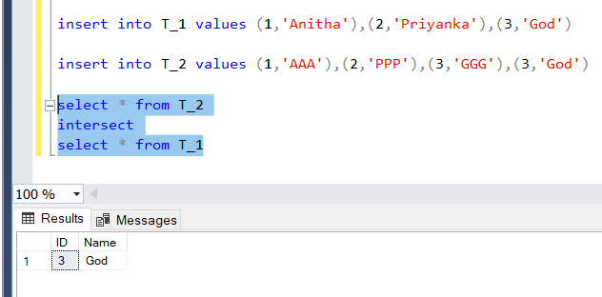

**Except 🡪 Uncommon but from the left (first) table.**

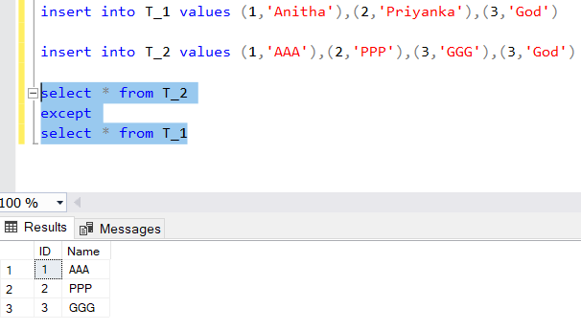

**To create a New Table Skeleton from an Existing table (Without copying data)**

select * into T_3 from T_1 where 1=2

